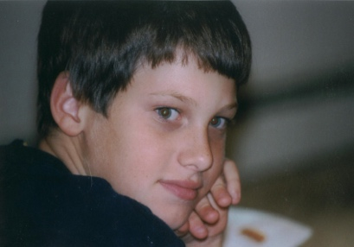  Ryan Patrick Halligan  1989 – 2003 | YOU’RE INVITED TO A SPECIAL  PARENT EVENING Program  Ryan’s Story  A Father’s Hard-Earned Lessons about  Cyberbullying and Suicide

Presented by John Halligan, father of Ryan Patrick Halligan
As seen on ABC’s Primetime, PBS Frontline, and Oprah
[Day of Week, Month Day, Year]
[Start Time] – [End Time] | [Venue Name, Address]
[Free admission / RSVP info]

In 2003, John lost his 13-year-old son Ryan to suicide after months of bullying and
cyberbullying. He now shares Ryan’s story so other families can be spared the same tragedy.
Parents will learn about:  - Bullying, cyberbullying and suicide prevention  - The latest statistics regarding suicidal ideation among teens  - Monitoring and guiding your child’s online activity | - Building open communication with your child about difficult topics  - The role of bystanders and how they can be upstanders instead  - Steps you can take tonight to protect your family

Over 2,000 schools | 1 million+ people reached | 20+ years of advocacy
This presentation could save a child’s life. Please make every effort to attend.

Learn more: www.RyanPatrickHalligan.org | Contact: [School contact name, phone, or email]
[School/Organization Name & Logo]

